Progress Report Template

Project Name/Description: Strengthening the health system through the integration of MISP of reproductive health in emergencies into basic midwifery training in the three provinces of DRC namely; Kasai, Central kasai and Oriental Kasai,
Quarter: 1st
Date Submitted: 10/12/2019

Background
A participatory planning sexual and reproductive health (SRH) workshop was held in Kinshasa, Democratic Republic of the Congo (DRC) on August 14-16, 2018 for 27 partners from the United Nations (WHO, UNFPA, UNICEF), Ministry of Health (PNSR), and civil society working in the field or in Kinshasa on SRH in Kasai, Kasai Central, and Kasai Oriental. The primary objective of the workshop – which was led by the World Health Organization (WHO)/Global Health Cluster (GHC) and UNFPA with the facilitation and support of the IAWG Training Partnership Initiative (TPI) – was to develop a collaborative work plan on expanding SRH services from the Minimum Initial Service Package (MISP) to comprehensive SRH care in the region (see workshop report for further information).
As follow-up to the workshop, two representatives from the IAWG-TPI traveled to Kinshasa and the three targeted provinces of the Kasai region with colleagues from the United Nations Populations Fund (UNFPA) DRC. The purpose of the visit was to:
- Visit midwifery schools in Kasai, Kasai Central, and Kasai Oriental to appreciate their level of readiness to introduce MISP in emergency settings into midwifery training curriculum
- Expedite progress towards solidifying the work plan for funding under the IAWG-TPI with emphasis on introduction of MISP in emergency settings into midwifery training curriculum at national level, quality of midwifery training and operational research
- Note progress to date on implementation of the priority activities identified as well as recommendations from the August 2018 workshop.
Project Background
The IAWG-TPI and the WHO/GHC are working in coordination to support select action items included in the workplans developed during the August 2018 workshop, using funding received by a shared donor – the Ministry of Foreign Affairs of the Netherlands – under their respective projects. For the WHO/GHC, this work falls under its effort to deliver integrated SRH services in emergencies through the GHC. For the IAWG-TPI, it is within its effort to further institutionalize the revised MISP for SRH – specifically objective six to plan for comprehensive SRH services, integrated into primary health care as soon as possible and to work with the health sector/cluster partners to address the six health system building blocks – at the field-level.
A total of six main activities (as listed in the workshop report) were prioritized and workplans developed during the workshop, including:
- The provision of comprehensive SRH services with two emphasized components:
  - Strengthening services with a focus on adolescents and young people.
  - Community engagement and mobilization for SRH to strengthen community systems.
- Updating and building existing providers’ skills so that human resources are trained in comprehensive SRH.
- The renovation of health centers and sustainable channels for the supply of commodities/inputs.
- Strengthening the health information system.
- Advocating to the government to harmonize the fees for SRH services.
- Advocating to donors for additional funding.

Given IAWG-TPI’s mission and focus on capacity development, the second activity, which falls under the health workforce building block, was targeted for investment. Using the results from this initial prioritization and planning workshop, given the existing funding, and in further consultation with lead workshop partners, the scope of this work was narrowed down to developing the capacity of midwives to provide comprehensive SRH services in the three targeted provinces of Kasai, Kasai Central and Kasai Oriental

Purpose/Objective
The overall purpose of the project is to reduce maternal and neonatal mortality by improving the skills of midwives and other health providers in providing comprehensive SRH services in the three targeted provinces of Kasai, central kasai and Eastern Kasai and integrating the MISP of reproductive health in emergency settings into basic midwifery training curriculum

Update on key activities

Progress made to date
Good progress has been made on all expected results and indicators of the project which are summarized as follows:
- The updated midwifery training program and MISP integrated into the initial midwifery training curriculum
- 3 midwifery training institutions equipped with appropriate training materials
- 2 midwifery training institutions ISTM Mbuji Mayi and ISTM Tshikapa benefit from rehabilitation of classrooms for the midwifery section
- 60 teachers and internship supervisors trained in practical student supervision techniques
- 75 teachers trained in new competency based training methods
- 15 clinical teachers from 03 above mentioned midwifery institutions w are trained in midwifery retraining
- 6 internship sites (2 per province) for midwifery training institutions are upgraded
- 180 health care providers are strengthened in the provision of comprehensive SRH services
- Conduct operational research to document the introduction of MISP for reproductive health in emergency settings into the midwifery training curriculum

Next steps
- The midwifery training equipment for ISTM Tshikaji in Kananga (Central Kasai) will be handed over to the institution in the first week of January 2020 when schools resume from the Christmas break
- 15 clinical teachers from 03 above mentioned midwifery institutions have been identified, and enrolled in the 18 months’ reconversion program in ISTM Kinshasa where they will undergo midwifery retraining starting January 2020

Challenges
- The banks in DRC and most especially Eco bank with whom UNFPA does business recently imposed a system where all bank transactions must comply with some 23 digits. This brought a lot of stress in most financial transactions as suppliers witnessed lots of delays and stress to have their money. The same applied to facilitators during workshops organized to capacitate health care providers on the provision of comprehensive SRH services in Mbuji Mayi and Kananga.
- No major technical challenges were encountered during this reporting period

Activities Undertaken:
- Midwifery training equipment has been purchased for the three midwifery training institutions
- Rehabilitation of skills labs in ISTM Mbuji Mayi and ISTM Tshikapa have been initiated
- Contractors have been recruited for the rehabilitation of classroom in the midwifery training institutions of Tshikapa and Mbuji as well as skills laboratories. Their contracts are being processed in the system and rehabilitation is expected to be complete by mid-February latest
- 120 health care providers have been strengthened in the provision of comprehensive SRH services in Kananga and Mbuji Mayi
- Terms of reference have been developed and the consultancy to conduct operational research and document the introduction of MISP for reproductive health in emergency settings into the midwifery training curriculum has been advertised

Activities Completed:
- The initial midwifery training programme has been revised/updated integrating MISP for reproductive health in emergencies into midwifery training curriculum and the program adapted to the LMD system
- 60 teachers and internship supervisors from the three midwifery training institutions have been trained in practical student supervision techniques
- 75 teachers have been trained in new competency based training methods
- Midwifery training institution (ISTM) Mbuji Mayi has been provided with midwifery training materials

Activities planned for next quarter:
- 6 internship sites (2 per province) for midwifery training institutions are upgraded
- Complete the rehabilitation of classrooms in the midwifery sections of ISTM Tshikapa and Mbuji as well as skills laboratories
- 60 health care providers in Tshikapa will be strengthened in the provision of comprehensive SRH services
- Conduct operational research to document the introduction of MISP for reproductive health in emergency settings into the midwifery training curriculum
- Present the preliminary results of this project in the upcoming Inter-Agency Working Group (IAWG) on Reproductive Health in Crises’ meeting in Bangkok, Thailand in February 2020

Some pictures

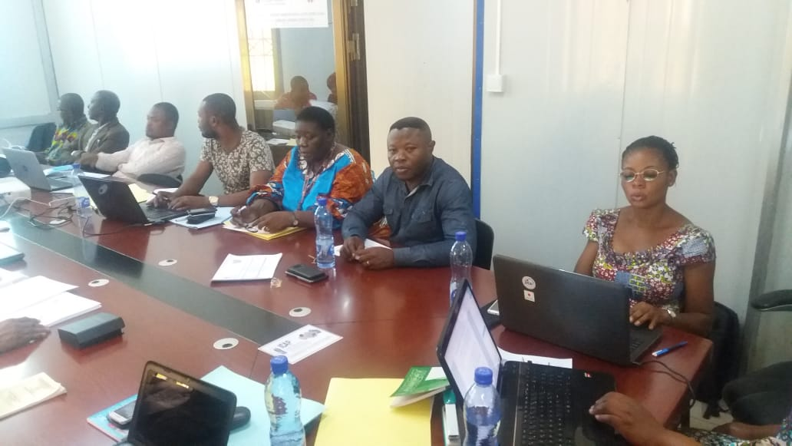
Workshop on the revision of the initial midwifery training programme to integrate MISP for reproductive health in emergencies into midwifery training curriculum and the program adapted to the LMD system

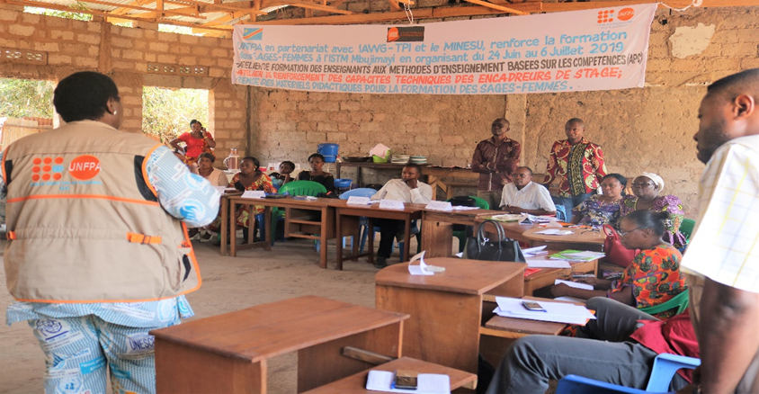

Capaciting teachers and internship supervisors from the three midwifery training institutions in practical student supervision techniques

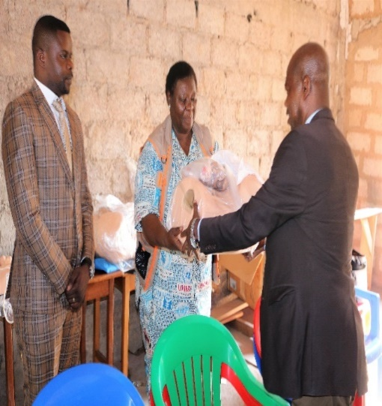

The Representative of the Ministry of Higher Education and Universities receives symbolically midwifery training materials from the Country Midwifery Adviser of UNFPA and hands them over to the Representative of the Management Committee of ISTM Mbuji Mayi

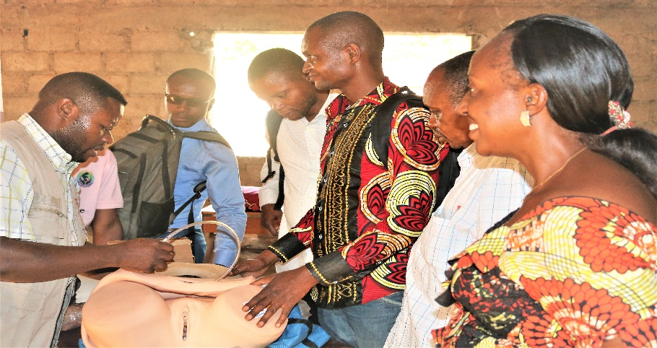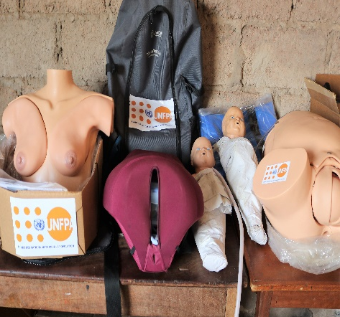

Demonstration session on new competency based training methods including the use of midwifery training equipment

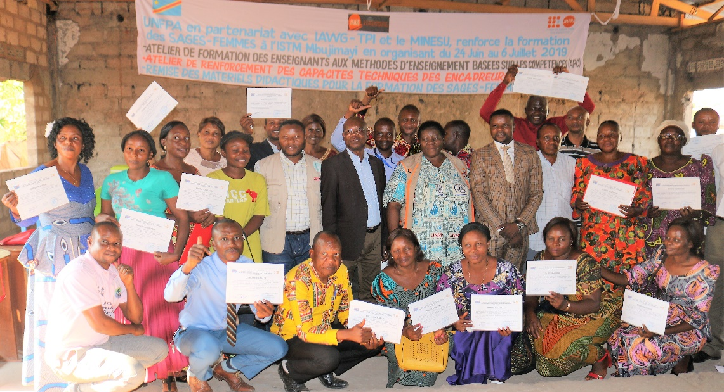
Teachers and internship supervisors at the close of a training session happily brandishing their certificates in Mbuji Mayi

